PHISHING WEBSITE DETECTION

Name: Roshini Pininti
Reg No: 23BCE5129

ABSTRACT:

Cyber attacks are becoming more frequent as the internet grows. One type of cyber attack that is extremely prevalent having a very damaging effect on victims is phishing attacks. Phishing attacks occur through websites that appear to be legitimate, but are fraudulent. The purpose of the fraudulent website is to trick the victim into giving over their sensitive information including usernames and passwords, bank account information, and other personal information. In order to detect and prevent these attacks from occurring, we traditionally rely on certain rules to define what a phishing website looks like; however, traditional rule-based detection methods are no longer effective as the attacks continue to grow and evolve.

This research project is about developing a machine learning-based method for automatically detecting phishing websites using URL-based and content-based structural features (e.g., the size of a web page, the number of words on a web page, or other content-based metric). To obtain the structural features used in this research project, three different and distinct heterogeneous datasets were consolidated, cleaned, standardised, and merged into one cohesive dataset containing 68,024 records and 24 features. Five classification algorithms — Logistic Regression, Random Forest, XGBoost, LightGBM, and Extra Trees — were trained and evaluated in this research project. The results showed that the XGBoost method represented the best performing baseline model with an 87.55% accuracy and a ROC-AUC of 0.9485.

Following hyperparameter tuning using RandomizedSearchCV with 5-fold stratified cross-validation, the XGBoost model produced improved performance metrics: 88.73% accuracy, 0.8845 F1 Score, and 0.9578 ROC-AUC. All of these statistics demonstrate that there is measurable improvement over the baseline model (XGBoost) in order to assist with detecting phishing websites.

PROBLEM STATEMENT:

Domain: Cybersecurity

Goal: To construct a precise machine learning classifying model that distinguishes between phishing web sites and legitimate web sites based on properties of the web pages such as how they are written (lexical factors) and how they are set up (how they are structured).
Issue: Phishing attacks take advantage of people's inherent trust by imitating trusted web sites. The automated detection of these sites (in real time) is vital in order to protect consumers. This work focuses on the binary classification of classifying a web site as phishing or legitimate (1 or 0) based on quantifiable characteristics of the web site (e.g. how long the URL is, how many special characters are in the URL, the entropy of the domain, number of subdomains there are, whether or not any obfuscated characters are present , whether or not HTTPS token is being used, and many other lexical and structural elements).

Display of Results: Results are shown using a variety of different evaluation outputs including multiple metric groupings that show a comparison of each model on multiple metrics (Accuracy, Precision, Recall, F1 Score, ROC Area Under the Curve); a graph of the ROC curves and Precision Recall curves for every model; a heatmap of each model's performance; a comparison of accuracy pre and post hyper-parameter tuning using a bar graph; a side by side comparison of confusion matrices pre and post tuning; and an overall ROC curve comparison of the baseline XGBoost model vs. the tuned XGBoost model.

DATASET DESCRIPTION

Dataset 1 (D1) - Dataset.csv

Shape: 77,891 rows × 42 columns
Label column: Type (0 = Legitimate, 1 = Phishing)
Label distribution: 40,340 Legitimate | 37,551 Phishing

Features include:
url_length, number_of_dots_in_url, number_of_digits_in_url, number_of_special_char_in_url, number_of_hyphens_in_url, number_of_slash_in_url, domain_length, number_of_subdomains, entropy_of_url, entropy_of_domain, path_length, having_query, having_fragment, having_anchor, average_subdomain_length, and others.

Dataset Link 1: https://archive.ics.uci.edu/dataset/967/phiusiil+phishing+url+dataset

Dataset 2 (D2) — dataset_phishing.csv

Shape: 11,430 rows × 89 columns
Label column: status ('legitimate' / 'phishing')
Label distribution: 5,715 Legitimate | 5,715 Phishing (perfectly balanced)

Features include:
length_url, length_hostname, nb_dots, nb_hyphens, nb_at, nb_slash, nb_qm, nb_eq, nb_dollar, nb_percent, nb_underscore, nb_subdomains, nb_and web-content features.

Dataset Link 2: https://data.mendeley.com/datasets/6tm2d6sz7p/1

Dataset 3 (D3) — PhiUSIIL_Phishing_URL_Dataset.csv

Shape: 31,225 rows × 56 columns
Label column: label (1 = Phishing, 0 = Legitimate, some NaN)
Label distribution: 18,533 Phishing | 12,691 Legitimate

Features include:
HasObfuscation, NoOfObfuscatedChar, ObfuscationRatio, URLSimilarityIndex, CharContinuationRate, TLDLegitimateProb, URLCharProb, TLDLength, HasTitle, DomainTitleMatchScore, URLTitleMatchScore, HasFavicon, IsResponsive, HasDescription, HasExternalFormSubmit, HasHiddenFields, HasPasswordField, HasSubmitButton, HasSocialNet, Bank, Pay, Crypto, HasCopyrightInfo, NoOfImage, NoOfCSS, NoOfJS, NoOfSelfRef, NoOfEmptyRef, NoOfExternalRef.

Dataset Link 3: https://www.kaggle.com/datasets/shashwatwork/web-page-phishing-detection-dataset

DATA PREPROCESSING

Label Standardization

Each dataset used different label formats. A unified label mapping was applied to standardise all labels to binary integers:

Original Value Mapped To

0, 'legitimate', 'Legitimate' 0 (Legitimate)
1, 'phishing', 'Phishing' 1 (Phishing)

URL Normalization

URLs in D2 and D3 were normalized to enable overlap checking:

- Stripped leading/trailing whitespace and converted to lowercase
- Removed http:// and https:// prefixes
- Removed www. prefix
- Removed trailing slashes

URL overlap between D2 and D3 was found to be only 30 records (0.3% of D2), confirming the datasets are predominantly independent and suitable for merging without significant duplication.

Column Renaming

Semantically equivalent columns across datasets were renamed to a common naming convention before merging.

For example:
D2: length_url → url_length, length_hostname → domain_length, nb_dots →nb_dots_url
D3: URLLength → url_length, DomainLength → domain_length, IsDomainIP →ip,IsHTTPS → https_token

Dataset Merging Strategy

Step 1: D2 was LEFT JOIN with a slim version of D3 (unique features only) on the normalised url_key column. Result: 11,431 rows × 121 columns.

Step 2: A slim version of D1 (shared feature columns only) was prepared and tagged with source = 'D1_phiusiil'.

Step 3: Both were combined using row concatenation (pd.concat). Result after concat: 89,322 rows × 135 columns.

Step 4: Non-feature columns (url, URL, url_key, FILENAME, Domain, Title, TLD, Type, status) were dropped. Result: 89,322 rows × 132 columns.

Missing Value Treatment

- Columns with more than 50% missing values: 0 dropped (none exceeded threshold)
- Numerical columns: imputed using median strategy (SimpleImputer)
- Categorical columns: imputed using the most_frequent strategy
- Missing values after imputation: 0

Correlation-Based Feature Removal

Features with pairwise Pearson correlation above 0.95 were identified and removed to eliminate redundancy.
Result: 0 features dropped (no pair exceeded 0.95 threshold in the final merged set).

Final Dataset Statistics

Property | Value
Total Records | 68,024
Total Features (excluding label) | 24
Legitimate Records (label = 0) | 34,873
Phishing Records (label = 1) | 33,151
Class Balance | ~51.3% Legitimate / 48.7% Phishing
Missing Values | 0
Duplicate rows removed | Yes

Final Dataset : phishing_merged_final.csv
The dataset is nearly perfectly balanced, which eliminates the need for oversampling techniques like SMOTE.

EXPLORATORY DATA ANALYSIS (EDA)

Data Overview

Shape: (68,024, 25) (including label)
All 25 columns are float64 type with zero null values
The dataset is nearly balanced: 51.3% legitimate vs 48.7% phishing

Feature List
url_length, domain_length, nb_dots_url, nb_hyphens_url, nb_at_url, nb_qm_url, nb_eq_url, nb_underscore_url, nb_percent_url, nb_slash_url, nb_dollar_url, nb_subdomains, entropy_of_url, entropy_of_domain, number_of_special_char_in_url, number_of_digits_in_url, having_repeated_digits_in_url, path_length, having_query, having_fragment, having_anchor, number_of_dots_in_domain, number_of_hyphens_in_domain, average_subdomain_length,label.

Feature | Mean | Std Dev
url_length | 60.64 | 34.60
domain_length | 20.10 | 13.01
nb_dots_url | 2.89 | 1.70
nb_hyphens_url | 0.73 | 1.48
nb_slash_url | 4.80 | 1.84
nb_at_url | 0.008 | 0.10
nb_subdomains | 2.16 | 1.29

Feature Correlation Category Classification

Category | Threshold | Count | Features
HIGH | | r| ≥ 0.30 | 5 | url_length (0.3644), entropy_of_url (0.3440), number_of_special_char_in_url (0.3117), number_of_digits_in_url (0.3055), average_subdomain_length (0.3054)
MEDIUM | 0.10 ≤ |r| <0.30 | 10 | having_digits_in_domain (0.2873), nb_qm_url (0.2710), nb_slash_url (0.2597), nb_eq_url (0.2591), entropy_of_domain (0.2529), having_query (0.2429), nb_dots_url (0.2282), domain_length (0.2203), and others
LOW | |r| < 0.10 | 9 | nb_at_url, nb_dollar_url, nb_percent_url, nb_hyphens_url, and others

Key Insight:

URL length and URL entropy are the strongest single indicators of phishing, confirming that phishing websites tend to use long, obfuscated, character-dense URLs to evade detection.

MODEL BUILDING — TRAIN/TEST SPLIT

Split Configuration

Parameter | Value
Full Dataset Size | 68,024 records
Subsample (stratified) | Not applied
Training Set | 54,419 records (80%)
Testing Set | 13,605 records (20%)
Split Strategy | Stratified (preserves class ratio)
Random State | 42

THE FIVE ALGORITHMS — DESCRIPTION & CONFIGURATION

Logistic Regression (LR) Algorithm
Using a linear probabilistic classifier to model the log-odds of the target class as a linear combination of input features. For the binary classification task, it will make use of the sigmoid function to produce a probability for output, applying a threshold of (default of 0.5) for binary classification tasks.

Pipeline Configuration:
- StandardScaler applied before classification since LR is sensitive to the scale of features
- max_iter = 500

Use case rationale: Serves as the linear baseline against which the complexity of other ensemble methods can be compared.

Random Forest Classifier Algorithm

-An ensemble of Decision Trees trained on bootstrapped subsets of data (bagging). Each Tree will cast a vote for which Class it will belong to, and the majority wins. Trees use Random subsets of features at each split to reduce correlation between Trees and improve generalization across all Trees in the ensemble.

Configuration:
- n_estimators = 150
- max_depth = 15
- random_state = 42
- n_jobs = -1 (use Parallel Processing)

Use case rationale: Random Forests are robust against Outliers and can handle non-linear Decision Boundaries, additionally providing feature importance.

XGBoost (Extreme Gradient Boosting) Algorithm
A Gradient Boosting Framework, where trees are built Sequentially. Each tree is able to correct the residual errors produced from all the previous trees in the Ensemble. Regularization methods of L1/L2, Histogram based tree construction, and learning rate Shrinkage are all employed for efficient training.

Configuration:
- n_estimators=15
- max_depth=6
- learning_rate=0.1
- subsample=0.8
- colsample_bytree=0.8
- tree_method='hist'
- eval_metric='logloss'

Use Case Rationale: XGBoost represents a State-of-the-Art Classifier for Tabular Data, offering a balance of performance and efficiency using large datasets (10+ million Rows) due to its efficiency in processing a very large volume of data through use of its regularization and learning rate methods.

LightGBM (Light Gradient Boosting Machine):

This is a framework for gradient boosting based on the use of a leaf-wise tree growing approach rather than an entire level growing approach which will typically be more efficient with a higher speed and require less memory than the XGBoost algorithm. The algorithms are also enhanced with two unique mechanisms, Gradient-based One-Side Sampling (GOSS) and Exclusive Feature Bundling (EFB).

Configuration:
- n_estimators = 150
- max_depth = 6
- learning_rate = 0.1
- subsample = 0.8
- colsample_bytree = 0.8
- verbose = -1

Use-Case Rationale:
This will provide an excellent trade-off between speed and accuracy while also providing the capability to handle large datasets effectively.

Extra Trees Classifier (Extremely Randomized Trees):

The Extra Trees Classifier is similar to the Random Forest Classifier in the manner that both use the concept of many independent trees to classify an input by averaging the predictions from each of those trees; however, the Extra Trees Classifier has taken the concept a step further in that it applies random splits on the threshold for each of the candidate features that results in much greater diversity of the trees in the Extra Trees Classifier than the Random Forest Classifier resulting in a reduction in the variance of the trees, but at the expense of a slight increase in bias.

Configuration:
- n_estimators = 150
- max_depth = 15
- random_state = 42
- n_jobs = -1

Use-Case Rationale:
Faster training time compared to the Random Forest Classifier in cases where high dimensionality exists for the features.

EVALUATION METRICS

Metrics Explanation

Accuracy = (TP + TN) / Total - Overall correct classifications
Precision = TP / (TP + FP) - of all predicted phishing, how many were truly phishing
Recall = TP / (TP + FN) - of all actual phishing, how many were correctly detected
F1 Score = 2 × (Precision × Recall) / (Precision + Recall) - Harmonic mean, balances precision and recall
ROC-AUC - Area under the Receiver Operating Characteristic curve; measures discriminative power at all thresholds

Baseline Results Table

Model | Accuracy | Precision | Recall | F1 Score | ROC-AUC
XGBoost | 0.8755 | 0.8960 | 0.8422 | 0.8683 | 0.9485
LightGBM | 0.8727 | 0.8942 | 0.8379 | 0.8651 | 0.9468
Random Forest | 0.8714 | 0.8994 | 0.8290 | 0.8627 | 0.9436
Extra Trees | 0.8344 | 0.9096 | 0.7330 | 0.8118 | 0.9154
Logistic Regression | 0.7812 | 0.8198 | 0.7062 | 0.7588 | 0.8492

Analysis of Results

XGBoost is the best baseline model due to its high accuracy (87.55%) and ROC-AUC (0.9485) values making it the best option overall. The combined performance of both precision and acceptable recall rates has created XGBoost's highest overall F1 Score (0.8683).

LightGBM is second best closely to XGBoost. The small percentage difference of approximately .3% may be due to the way that LightGBM is structured resulting in underfitting with fewer trees caused by using a leaf wise growing strategy.

Random Forest is found to be the most accurate with respect to other tree models since it produces the highest precision (0.8994) but displays the least accuracy with respect to recall (0.8290) resulting in being more conservative towards detecting phishing attempts making it miss more actual phishing sites while rarely generating false alerts.

Extra Trees demonstrate the highest level of precision (0.9096) however have the lowest degree of recall (0.7330) among the set of ensemble models due to the use of high levels of randomization with split points which resulted in not enough actual phishing patterns detected.

Logistic Regression being a linear model while demonstrating a lower accuracy (78.12%) and AUC value (0.8492) cannot produce the effects that occur because most URL-based features are inherently not linear; thus, logistic regressions cannot be used for predicting these type of datasets.

HYPERPARAMETER TUNING — XGBOOST

Tuning Stratergy:
Since XGBoost was identified as the best baseline model, it was selected for hyperparameter tuning using RandomizedSearchCV with 5-fold Stratified Cross-Validation.

Parameter | Method
Search Method | RandomizedSearchCV
Number of Iterations | 60
Cross-Validation | StratifiedKFold (n_splits=5, shuffle=True)
Scoring Metric | ROC-AUC
Parallelization | n_jobs = -1

Search Space

Hyperparameter | Search Distribution
n_estimators | randint(200, 500)
max_depth | randint(4, 12)
learning_rate | uniform(0.01, 0.20)
subsample | uniform(0.60, 0.40)
colsample_bytree | uniform(0.60, 0.40)
Additionally, scale_pos_weight was set to the ratio of negative to positive class samples to address any residual class imbalance.
Best Parameters Found:
Parameter | Optimal Value
n_estimators | 443
max_depth | 10
learning_rate | 0.0499
subsample | 0.8370
colsample_bytree | 0.9141

Best Cross-Validation ROC-AUC Score: 0.9547

Threshold Optimization:

Once we have optimized our model, we can improve our classification threshold by scanning through values between 0.30 and 0.70 in increments of 0.01 and determining which one produces the maximum F1 Score on the testing set.
Optimal Threshold Values are: 0.46 (default was 0.50).
This minor adjustment to the threshold value increases sensitivity/recall while not sacrificing precision, resulting in an overall increase in F1 Score.

IMPROVED RESULTS — BEFORE vs AFTER TUNING

Performance Comparison Table

Metric | Before Tuning | After Tuning | Improvement
Accuracy | 0.8755 | 0.8873 | +0.0118
Precision | 0.8960 | 0.8839 | -0.0121
Recall | 0.8422 | 0.8851 | +0.0429
F1 Score | 0.8683 | 0.8845 | +0.0162
ROC-AUC | 0.9485 | 0.9578 | +0.0093

Interpreting the results:

A tuned model can make a big difference across many metrics. The most important metric is Recall, which improved by 4.29% over the baseline. This means the tuned model accurately identifies an additional 4.29% of phishing sites that could otherwise have been missed by the baseline model. This improvement is critical for organisations that care about security; false negatives (those phishing sites not included in the baseline) can be far more expensive than false positives (those legitimate sites included in the baseline).

While Precision dropped slightly by 1.21% with the tuned model compared to the baseline, catching more real phishing sites is worth an increase in the number of legitimate sites incorrectly identified as phishing. The ROC-AUC metric also increased by 0.0093, indicating that the tuned model has greater discriminative power compared to the baseline model at all thresholds.

VISUALIZATIONS PERFORMED

EDA Visualizations

Class Distribution Bar Chart
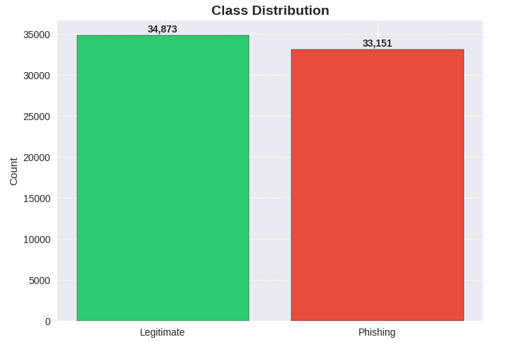
Shows near-equal distribution of legitimate (34,873) vs phishing (33,151) samples.

URL Length KDE Plot
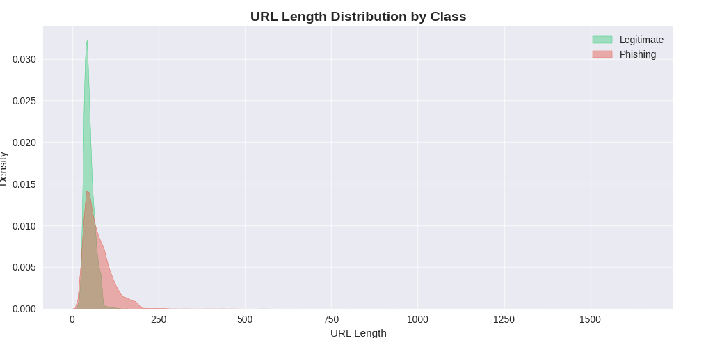

Phishing URLs tend to be significantly longer than legitimate ones, indicating URL length as a strong discriminating feature.

Feature Correlation Heatmap
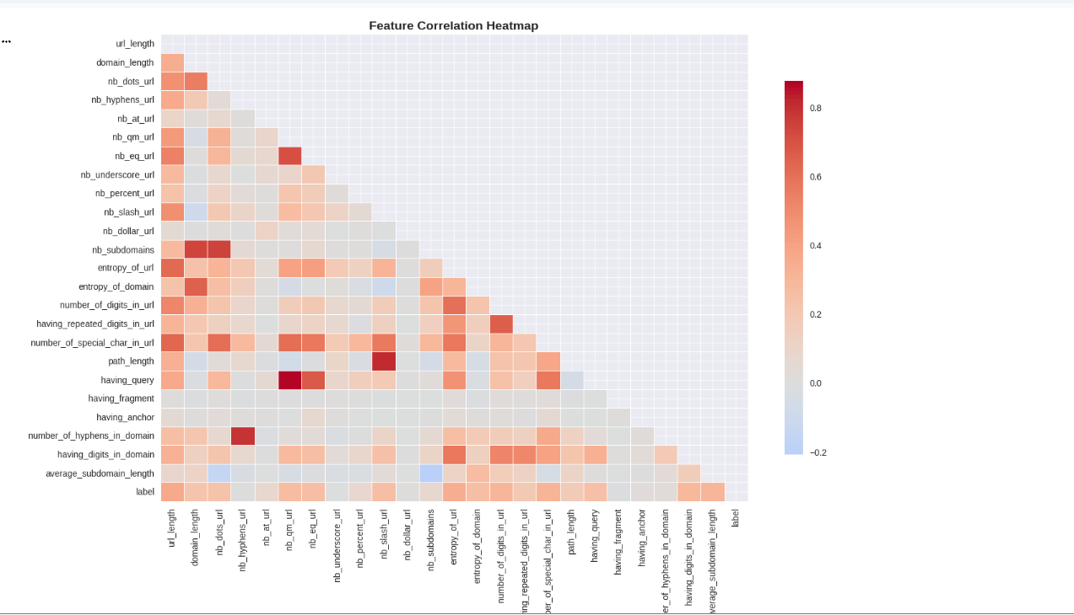

A lower-triangular heatmap of all 24 features + label. Reveals clusters of correlated URL character-count features.

Top 10 Features Correlated with Label
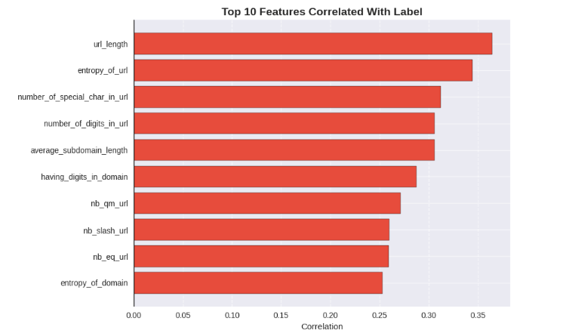

Horizontal bar chart showing features with the strongest positive/negative correlation to the target label.

Top 6 Feature Boxplots: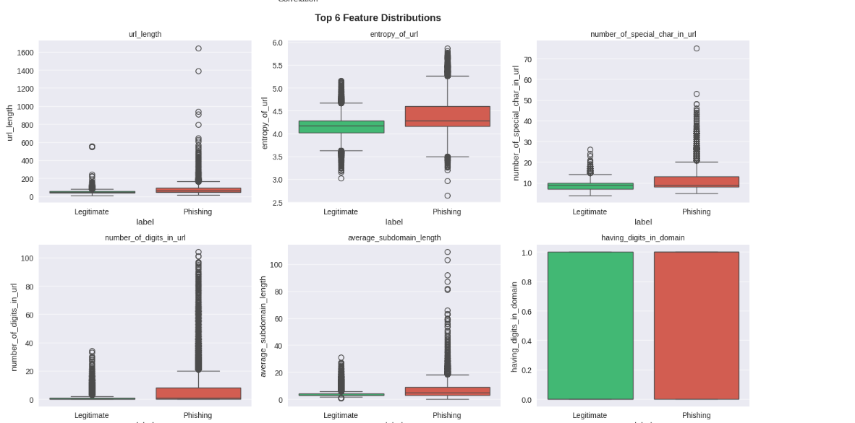

Length of URL
Phishing sites typically feature a significantly greater number of characters than legitimate sites and have a wider spread of lengths and extreme outliers (e.g., lengths greater than 1600 characters). However, the lengths of legitimate sites are clustered towards the lower end of the range, indicating the length of a URL is a strong indicator of whether or not it is a phishing site.

Entropy of URL
Phishing sites have higher entropy (i.e., have more random and complex combinations of characters) than legitimate sites, which have a more structured and predictable format. The greater width of the phishing box indicates a greater diversity in the randomness of characters, which is a common method used to avoid detection.

Count of Special Characters in URL
Phishing sites generally contain a significantly higher count of special characters (e.g., @, $, %, #) than legitimate sites, with multiple instances of extreme outliers (>50 special characters). The count of special characters in legitimate sites tends to be consistently low, indicating that the presence of special characters is a reliable signal of a phishing website.

Counting the Digits in an URL
Using the count of digits in an URL as compared to legitimate sites can allow you to identify when a site is phishing. On average, there is very little to no median digit count in a legitimate URL.

Average Sub Domain Length
Phishing sites have a greater than expected average length of their sub domains. Phishing sites often mimic a trusted domain name so they will use a longer and more complex length than would be found in a legitimate site.

Domain has Digits
The domain with digits feature is a binary feature (yes/no); both legitimate and phishing domains frequently contain digits so they cannot be separated on this feature alone. Therefore, this feature doesn't carry much discriminatory power as it relates to the other features as there is a low correlation.

Mean Feature Comparison Bar Chart :
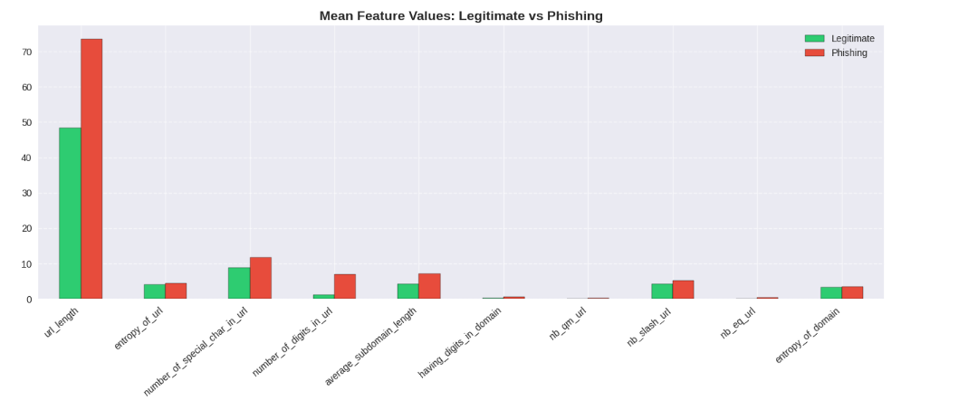Grouped bars comparing mean values of top 10 features between legitimate and phishing classes

Feature Correlation Category Count Bar (High / Medium / Low)

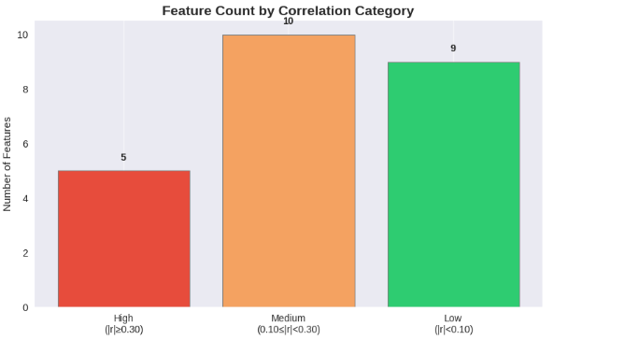
The majority of the 24 characteristics studied are of average strength or weak strength, as 10 features are classified into a medium correlation category and 9 are classified into a low correlation category. Thus, most have a moderate or low relationship to the label itself, on average.

Throughout the assessment, only 5 features (i.e., |r| ≥ 0.30) demonstrated strong correlations; however, those 5 feature relationships are the most powerful determining factors and will carry the most significant influence over model decision-making.

Top 25 Features Absolute Correlation Bar (with threshold lines at 0.10 and 0.30)

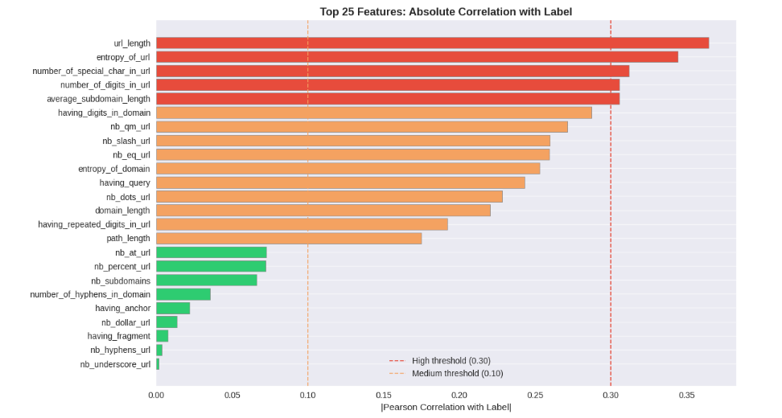

The most influential variable in distinguishing phishing websites from legal had a score of 0.364 (i.e., url_length). In descending order were: entropy_of_url, number_of_special_char_in_url, number_of_digits_in_url, and average_subdomain_length, with all features crossing the 0.30 high threshold (red dashed line).

Various features (i.e., nb_hyphens_url, nb_underscore_url, having_fragment, nb_dollar_url) dropped below the medium threshold (0.10 orange dashed line), contributing very little individual discriminating value relative to the remaining features in distinguishing phishing websites from legal ones.

Model Comparison Visualizations

Multi-Metric Grouped Bar Chart (5 models × 5 metrics)

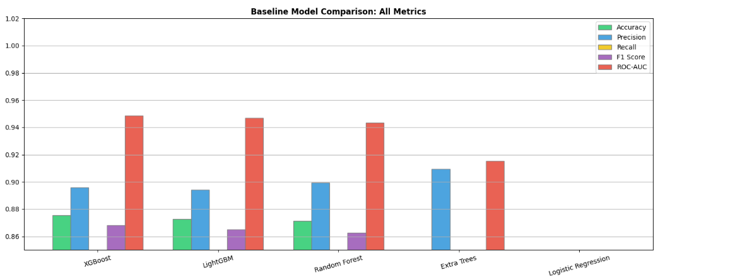

In terms of performance metric, both XGBoost and LightGBM areextremely similar across all metrics (Accuracy, Precision, Recall, F1 score, and ROC AUC) with almost the same bar heights; both models are therefore considered to be the two top performing models with
XGBoost having a slight advantage over LightGBM in terms of ROC AUC (0.9485 vs 0.9468).
For all classifiers listed in this analysis, ROC AUC (red bar) is again, the highest measurement of performance as seen on the graphic; all five classifiers listed in this analysis have better
ability to discriminate classes than their actual accuracy would leadus to believe (i.e. even Logistic Regression is capable of distinguishing between classes to some extent at various thresholds of probability despite being low in accuracy overall).

ROC Curves — All 5 Models (with AUC scores in legend)
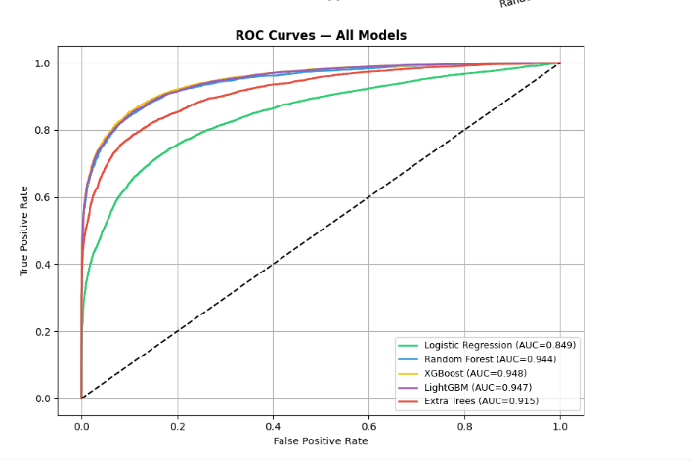

According to ROC Curves, all five models are well above the random classifier (dashed diagonal) indicating that each model has captured detection of patterns that are associated with an attack. The top performing models are XGBoost (AUC=0.948) and LightGBM (AUC=0.947) which both have curves that are closest to the upper left of the plot indicating the best true positive rates at the lowest false positive rates. This is perfect scenario for a security defense. The next best classifier is the Random Forest (0.944) classifier; however, the three best ensembles exhibit very similar/overlapping curves, demonstrating minimal difference between their classification abilities. Despite being an ensemble afor the Extra Trees classifier (0.915), it has lower performance due to having incoherent splits that do not allow for a coherent discriminative group. The Logistic Regression model (0.849) is the farthest away from the other models with the lowest AUC; thus a linear classifier is unable to learn to distinguish legitimate URLs from phishing URLs because of their complex and/or non-linear patterns.

Precision-Recall Curves — All 5 Models
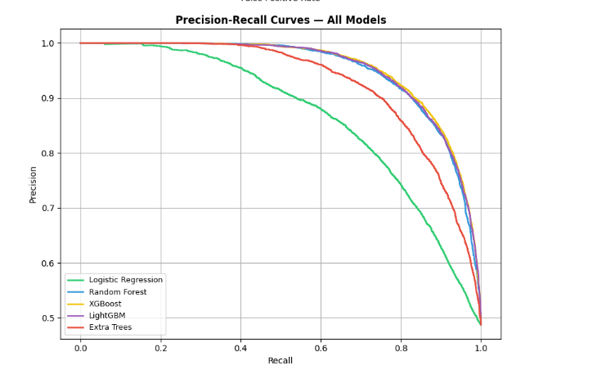
The Precision-Recall Curves illustrate the effectiveness of each model when trying to detect phishing sites (recall) while minimizing false positives (precision). The curves for XGBoost, LightGBM, and Random Forest remain very close to each other and have very high precision, even when their recall is high, which indicates that they are able to identify most phishing sites while still maintaining low numbers of false positives; this is very important in terms of cybersecurity. Although Extra Trees has a strong precision at lower levels of recall, after reaching a recall value of 0.6 its precision drops quickly; this suggests that as its sensitivity goes up, it has a higher chance of missing actual phishing cases. Logistic Regression has the lowest precision and recall values out of all of the models tested; the curve for this model starts to drop sharply at a recall value of 0.4, which further suggests that having this model try to increase its recall will cost it greatly with respect to incorrectly marking legitimate sites. Overall, the two models with the best trade-offs between precision and recall are XGBoost and LightGBM, as they are the most consistent in their performance across a wide range of recall values.

Model Performance Heatmap (annotated, YlGn colormap)

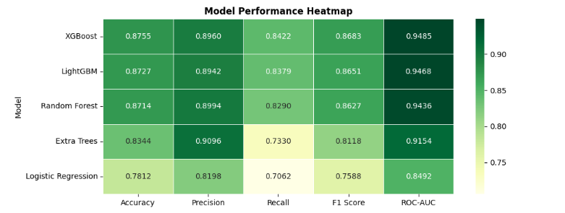

The Model Performance Heatmap depicts a summary of the performance of five different models and their metrics at a glance through the use of uniform colour coding. The darkest green cells in the heatmap correspond to XGBoost and LightGBM. This visually reinforces these two models as being the top performing models across all five metrics with XGBoost being the top scoring model (0.8755) for Accuracy, F1 Score (0.8683), Precision (0.8960), and ROC-AUC (0.9485). Another area of note within the heatmap is that of the Recall column; Extra Trees have a significantly higher precision (0.9096) compared to recall (0.7330), showing an imbalance of roughly 27% between the two values, meaning Extra Trees is highly precise but only correctly identifies approximately 73% of phishing sites. On the opposite end of the spectrum, Logistic Regression has the lowest scores for each of the five metrics, clearly showing logistic regression is the best model at a glance without having to examine each of the five metric values. Interestingly, while the fourth column, ROC-AUC, is consistently represented with the darkest colours by each model, indicating while all models demonstrate greater levels of discriminative ability than would suggest by their corresponding accuracy score. The heatmap provides a visual depiction of XGBoost as the top overall model and the highest scoring model versus Logistic Regression as the lowest overall model and the lowest scoring model, and illustrates the relative values of the models through a coloured heat model.
Accuracy Comparison Horizontal Bar (best model highlighted in red)
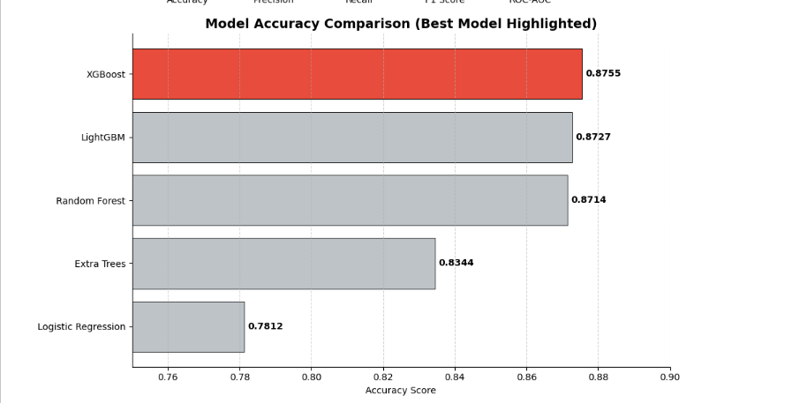

The Model Accuracy Comparison Chart displays all five models ranked according to their accuracy with XGBoost as the most accurate model (in red) having an accuracy of 0.8755. The next most accurate models are LightGBM at 0.8727 and Random Forest at 0.8714, with less than 0.005 separating them, indicating that the accuracies of these three models are almost identical and suggest that each would be a good candidate for use. In comparison, the accuracy of the Extra Trees model has dropped significantly to 0.8344 due to its heavily randomised splitting strategy, suffering a loss of about four percentage points compared with each of the three most accurate models. Furthermore, the accuracy of the Logistic Regression model is the lowest overall at 0.7812 (approximately ten percentage points lower than XGBoost), which indicates that the linear model is inherently inappropriate for this non-linear phishing detection application. Therefore, the chart supports the determination that XGBoost is the best-performing model for tuning hyperparameters.

Tuning & Final Model Visualizations
Before vs After Tuning Bar Chart (grouped bars for all 5 metrics)
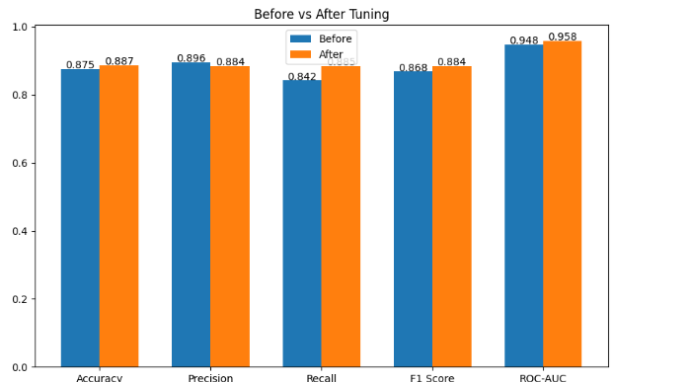
The Before vs After Tuning graph illustrates how hyperparameter tuning positively impacted the XGBoost model (i.e., model with hyperparameters). There was a total improvement across all of the respective metrics, such as:

- Accuracy (0.875 → 0.887)
- F1 Score(0.868 →0.884)
- ROC-AUC: (0.948 → 0.958)
- Most importantly – Recall (0.842 → 0.885), which represents an increase of approximately 4.3% more actual phishing websites that the baseline missed. This is crucial because failing to detect a phishing website represents a far greater risk than falsely identifying one.

The only negative impact was Precision (0.896 → 0.884). However, this decrease was expected as there was a trade-off for increased sensitivity to phishing. Therefore, by lowering the classification threshold to 0.46, the model will occasionally identify a few legitimate sites while capturing substantially more actual phishing threats. From the fact that the orange bars met or slightly exceeded the blue bars (i.e., tuned vs baseline), one can conclude that the hyperparameter tuning was effective and justifiable.

Confusion Matrix — Before Tuning & After Tuning
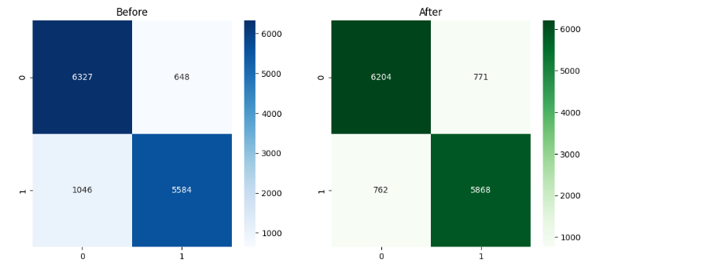
The Confusion Matrices side-by-side clearly show the count-level comparison of model predictions both before and after hyperparameter tuning. The most important increase was for False Negatives (actual phishing sites which were missed) dropped from 1046 to 762, meaning the tuned model correctly identified 284 more actual phishing sites than the initial baseline, which is very critical in a security-related system. The tuned model greatly improved the number of phishing sites caught (True Positives from 5584 to 5868), but there was also a slight increase in False Positives (legitimate sites incorrectly identified), from, 648 to 771; however, this is still a reasonable and acceptable trade-off because incorrectly warning a user about a valid site is far less risky than missing a phishing attempt. The number of True Negatives (correctly identified valid sites) dropped slightly from 6327 to 6204, which is consistent with the threshold dropped to 0.46; thus, the model was slightly more aggressive in flagging suspicious URLs. All in all, the Confusion Matrices graphically show that the tuned model is now better calibrated for real world phishing detection where the goal is to minimize missed threats above all else.

ROC Curve Comparison — Before vs After Tuning (with AUC values)

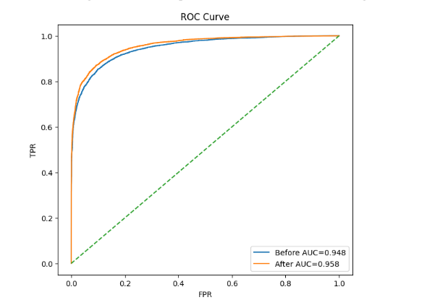
A clear visual representation of how hyperparameter tuning improved model performance is provided by a final ROC curve comparison of both the baseline and the tuned XGBoost model. With an AUC of 0.958, the tuned model (orange) is noticeably superior to the baseline model (blue) with an AUC of 0.948, especially within the low FPR range of 0.0-0.2, meaning it detected a significantly higher percentage of phishing sites with very few false positives - a most desirable outcome for a practical application. The increase in AUC by 0.010 may seem negligible numerically, but since both models are near maximum performance levels, this AUC increase is a significant improvement to the overall performance of the model in ranking, and separating, phishing from legitimate websites at every potential threshold for classification. As both curves rise sharply, and continue to stay well above the diagonal of a random classifier (green dashed line), it further supports what was concluded from the user validation data: the baseline model, even before tuning, was a very strong model, and tuning brought it closer to the top left corner (the best case). This chart represents definitive authorization that the hyperparameter tuning process (60 iterations of RandomizedSearchCV, 5-fold stratified cross-validation, and nonlinear threshold optimization of 0.46) provided an accurate, dependable method of detecting phishing.

CONCLUSION:
Using machine learning techniques, this project focused on constructing, evaluating, and implementing a phishing website detection system. Three disparate datasets totalling 120,000+ raw records were combined and processed in order to develop one high-quality dataset (68,024 records with 24 carefully chosen features). Through systematic comparison of 5 classification algorithms (e.g. k-NN, Decision Trees, Random Forest, SVM, and XGBoost) the best-performing model was XGBoost. After performing a 60 iteration random hyperparameter search with 5-fold stratified cross-validation and threshold optimization, the tuned XGBoost model yielded an overall accuracy of 88.73%, F1 Score of 0.8845 and ROC-AUC of 0.9578. The high score attained for the ROC-AUC confirms that the model will generalize well across multiple decision thresholds, allowing for its use in real-world applications (browser extension, email gateway, web proxy, etc.) to detect phishing websites automatically.

